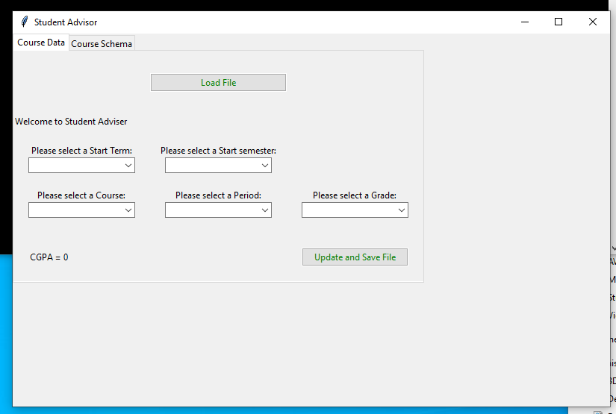

1. Run the Student_advisor.py as admin
2. Click on Load File and feed either csmajor or sophomore. Csmajor.txt and sophomore.txt was provided with in the folder
3. Select course Dropdown should show up the available courses as per the history and prerequisites.
4. Select period, and select grade and update and save file.
5. Studentadviser.txt would be saved in the same folder.
6. GPA would be calculated upon the first submission of GPA.

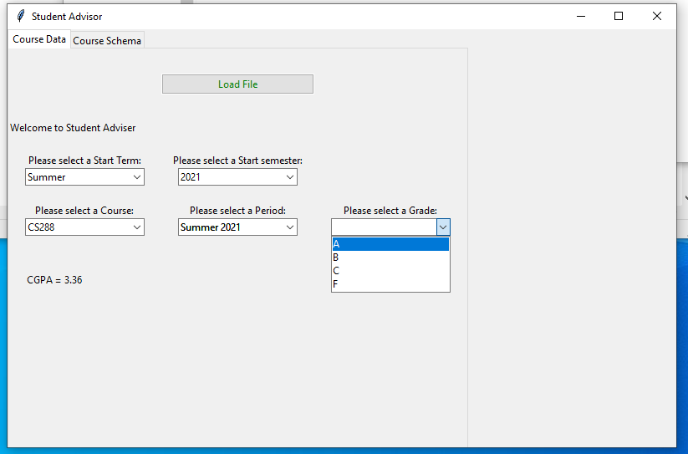

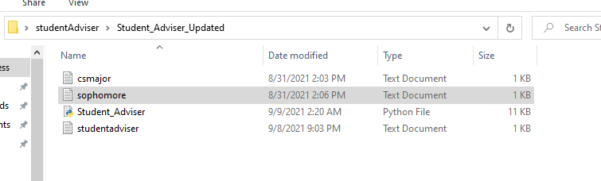

Couse Schema TAB can be used to see the status of updates without opening the saved file.

